Cascading Style Sheets (CSS)
CSS is a powerful style sheet language used to control the HTML document to improve the webpage design.
CSS Styles
Inline CSS
An inline CSS is used to apply a unique style to a single HTML element.
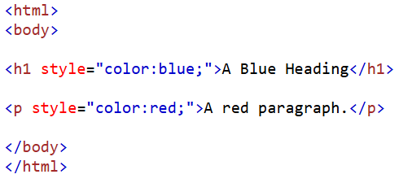
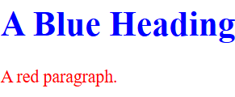
Internal CSS
An internal CSS is used to define a style for a single HTML page.
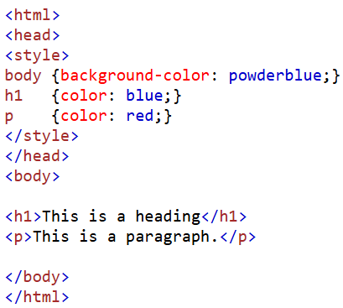
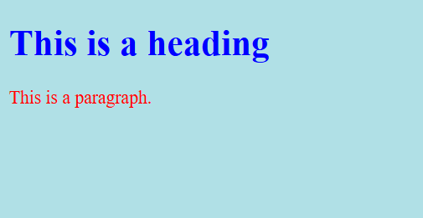

External CSS
An external style sheet is used to define the style for many HTML pages.
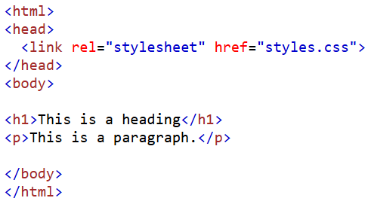

styles.css

body {
background-color: powderblue;
}
h1 {
color: blue;
}
p {
color: red;
}

CSS Syntax
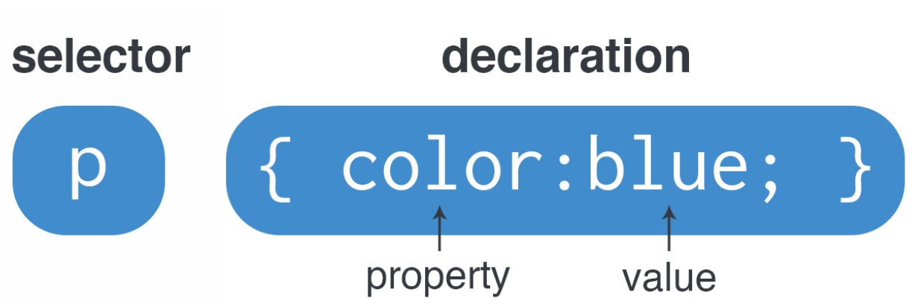

CSS Selectors
A CSS selector selects the HTML element(s) you want to style.
The CSS element Selector
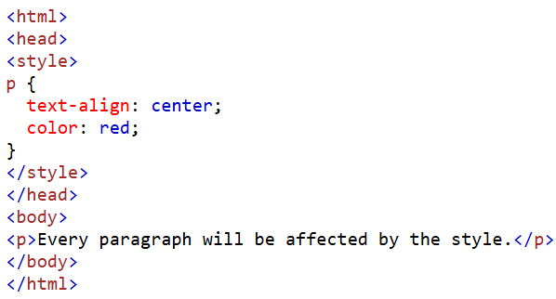
The CSS id Selector
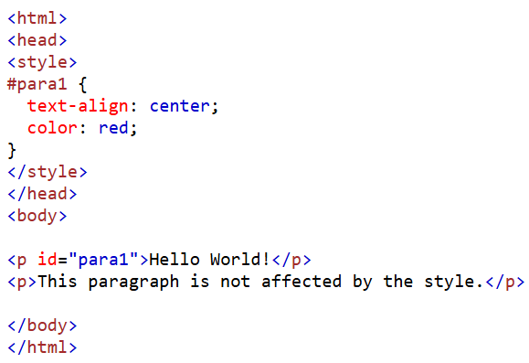
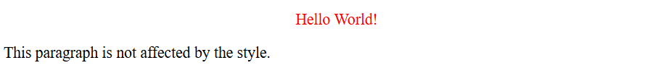
The CSS class Selector
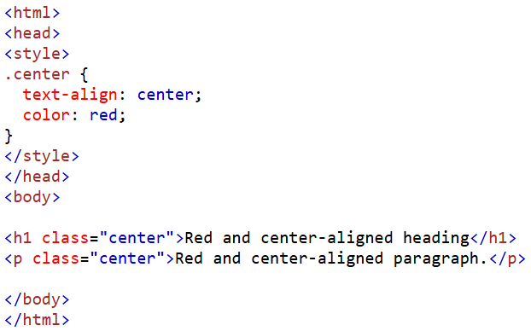
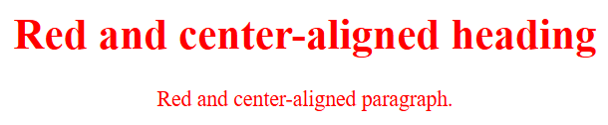
CSS Class Selector for specific element
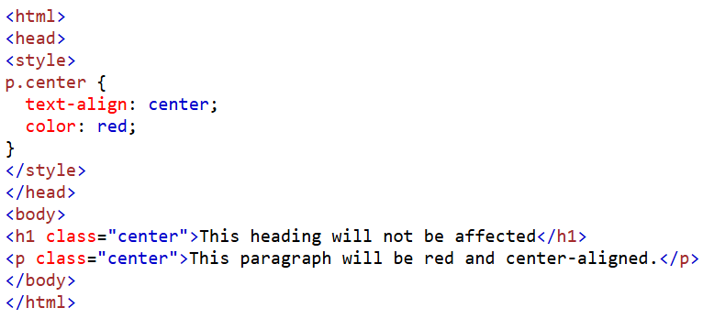
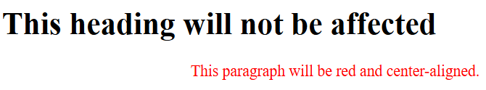
CSS Universal Selector
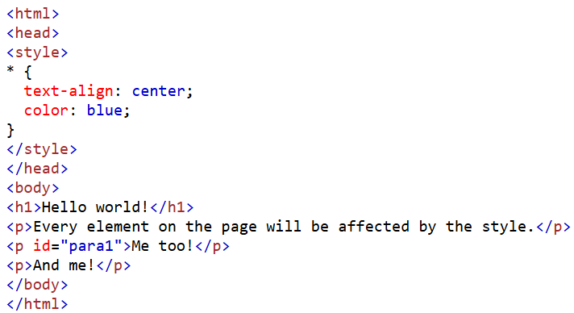
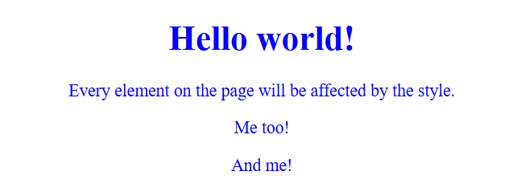

CSS Group Selector
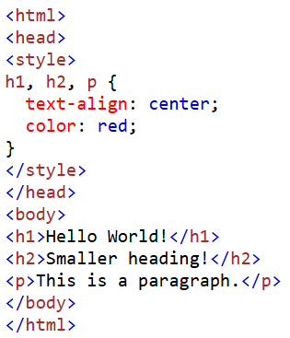
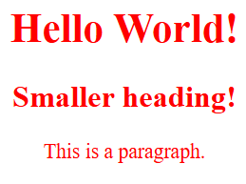
CSS Properties
Color Properties

pes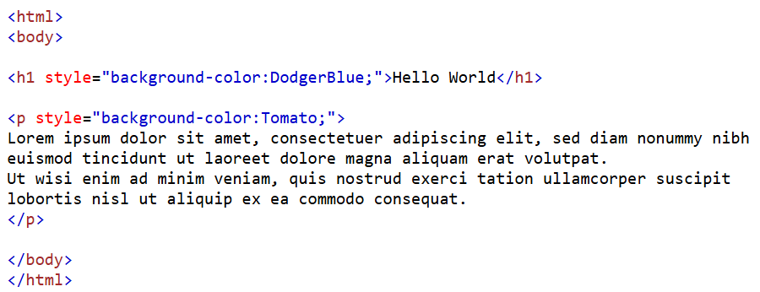
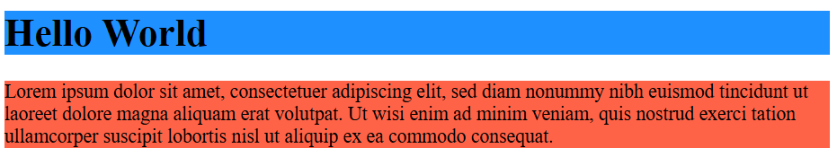

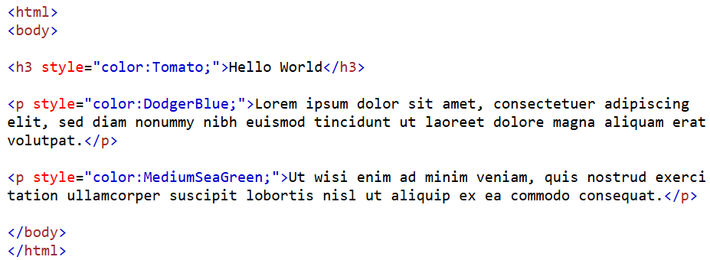
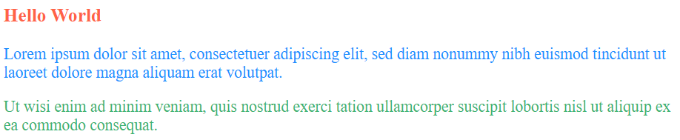

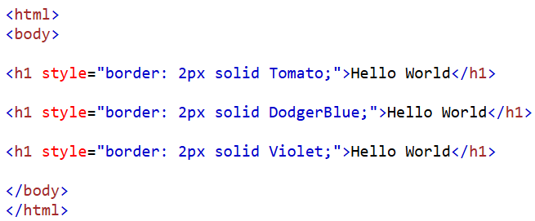
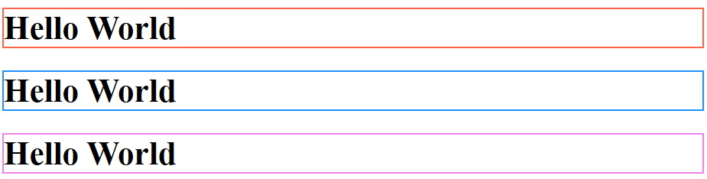

RGB
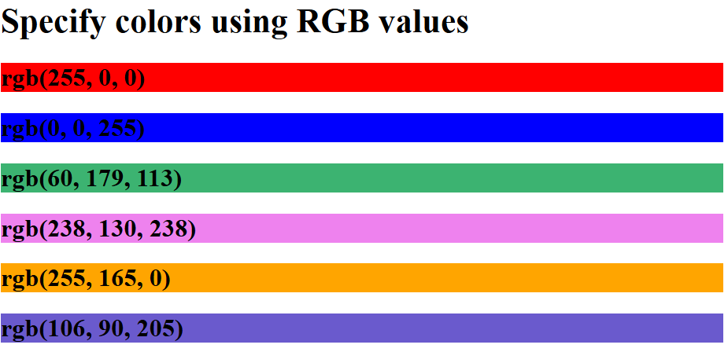
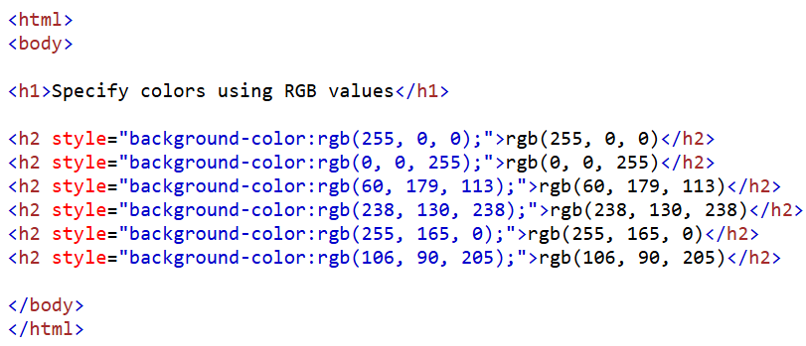
HEX
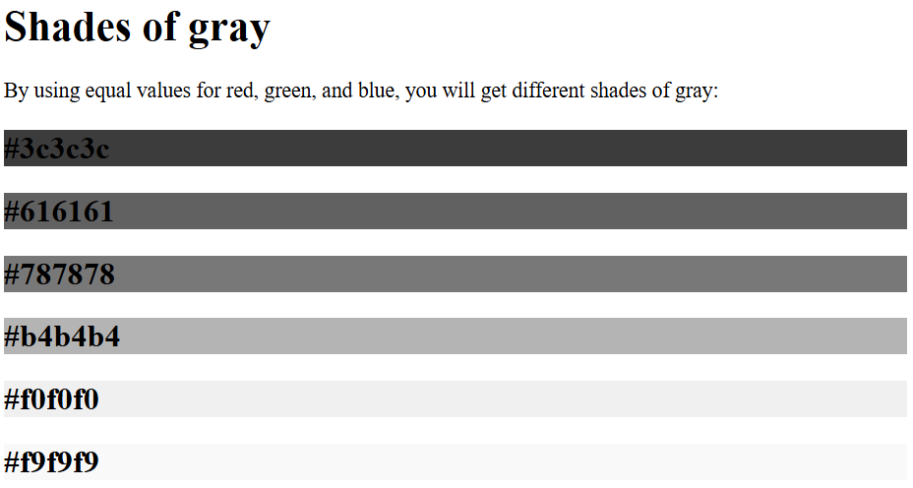
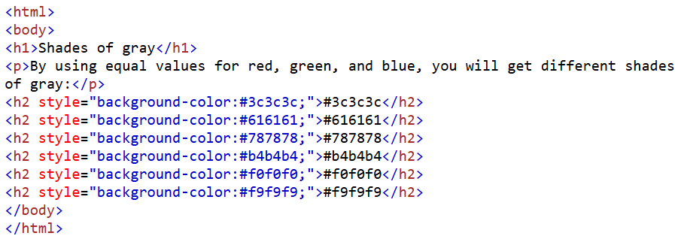
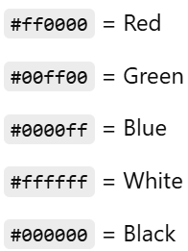
HSL(Hue, Saturation, Lightness)
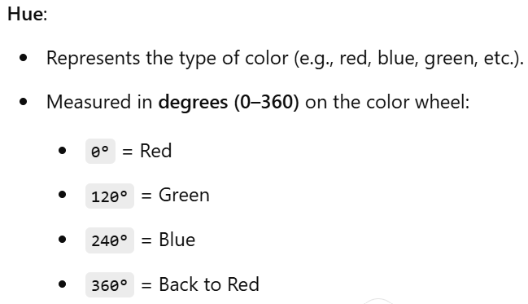
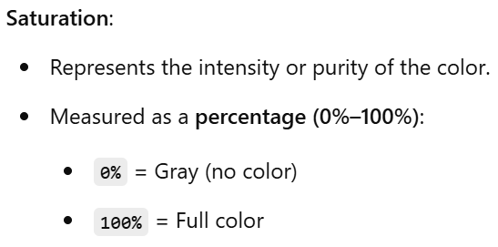
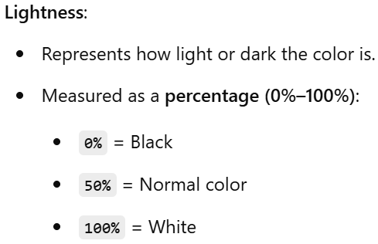
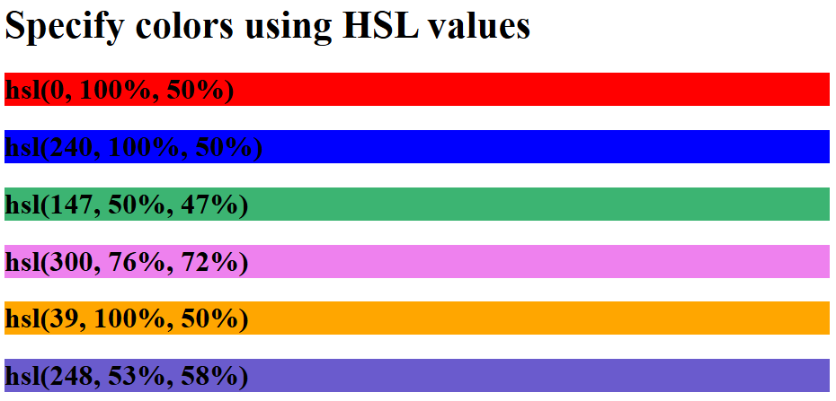
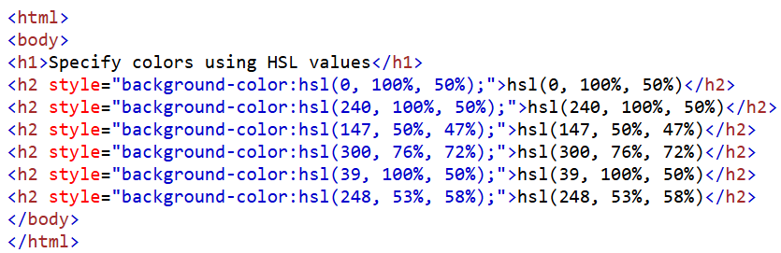
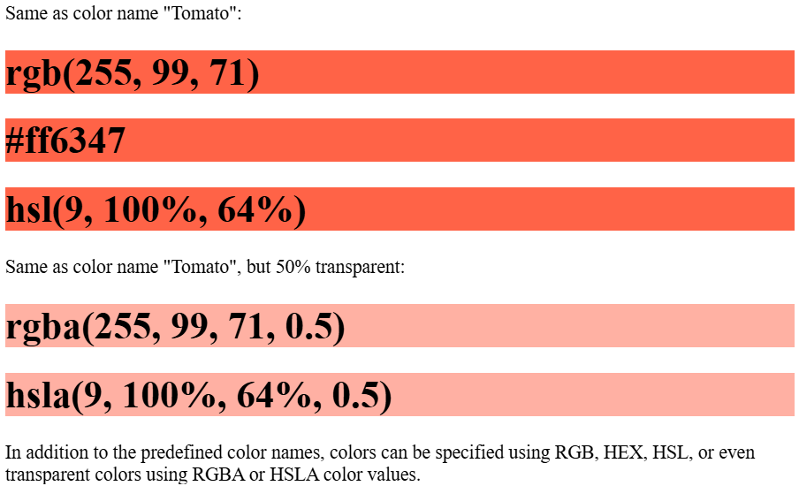
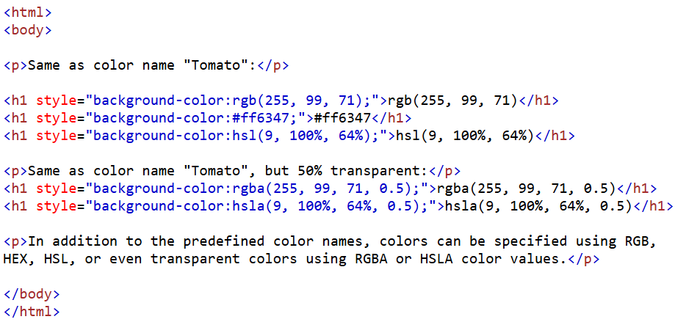
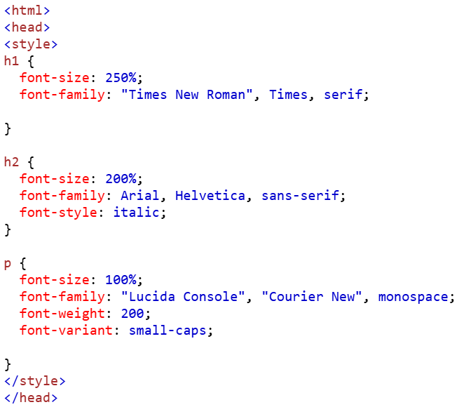
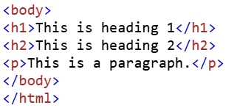
Font Properties
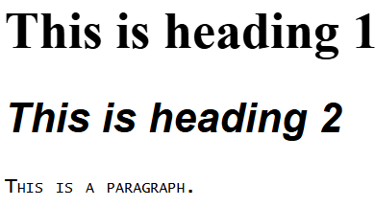

Text Properties
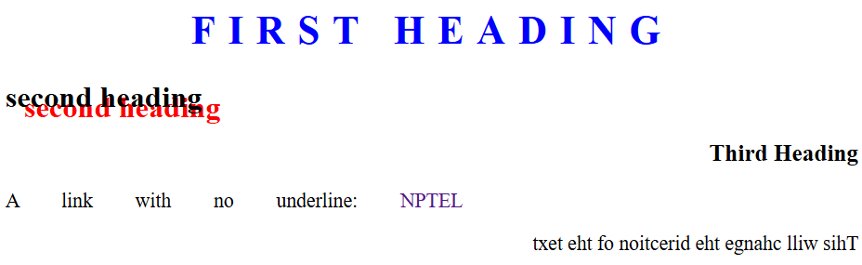
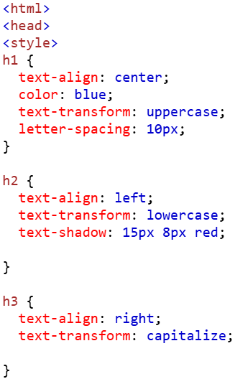
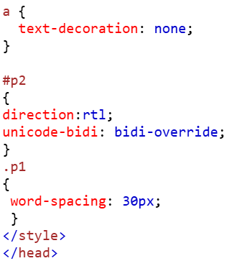
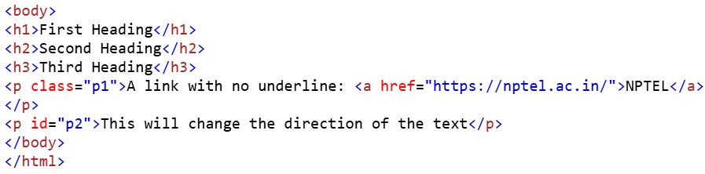

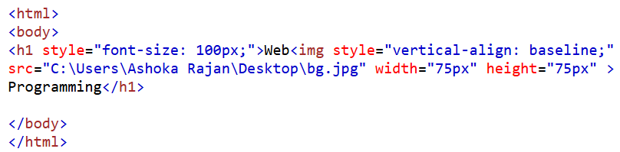
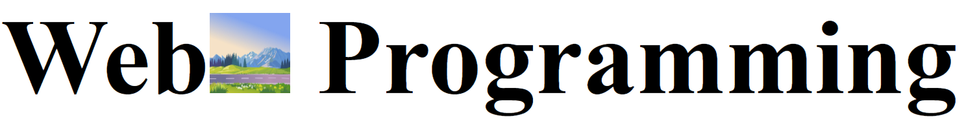
vertical-align: text-top;
vertical-align: text-bottom;
vertical-align: sub;
vertical-align: super;
Border Properties
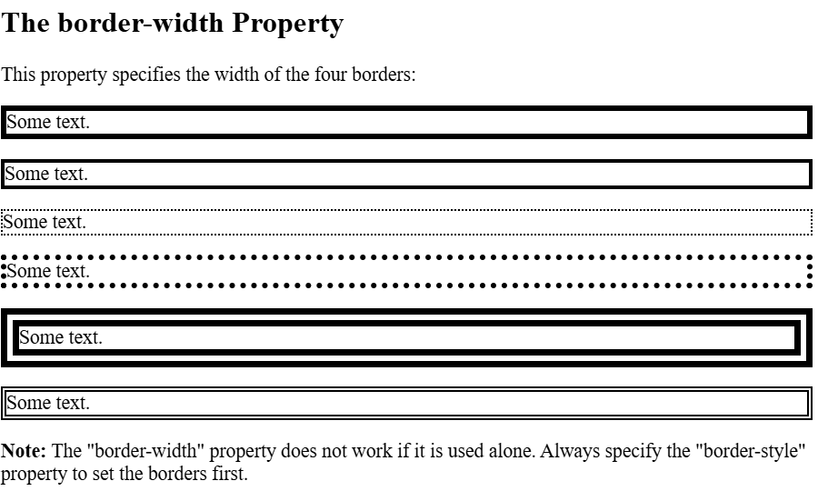
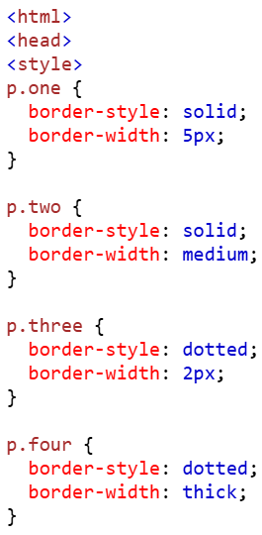
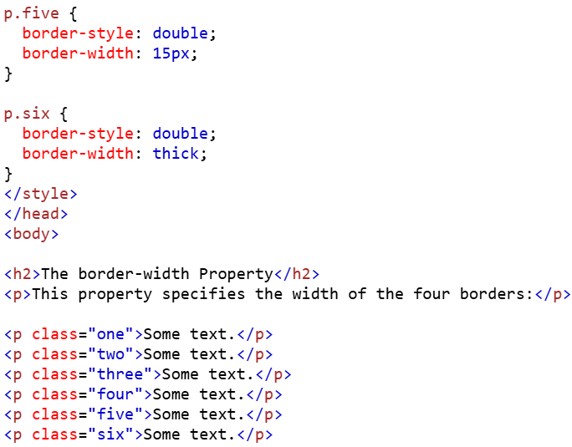
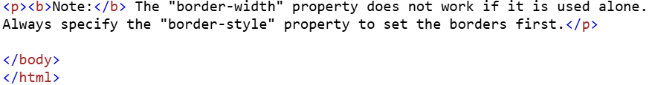
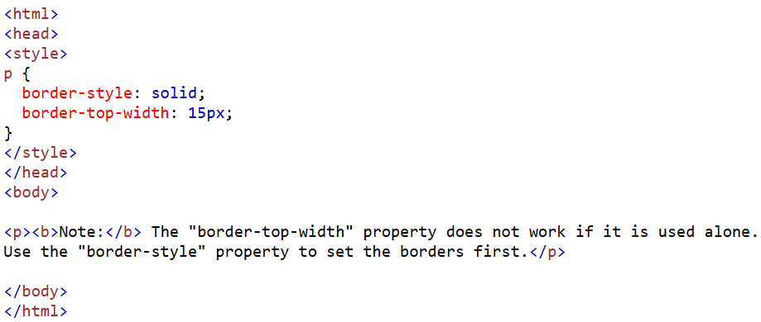
border-bottom-width: 15px;
border-left-width: 15px;
border-right-width: 15px;
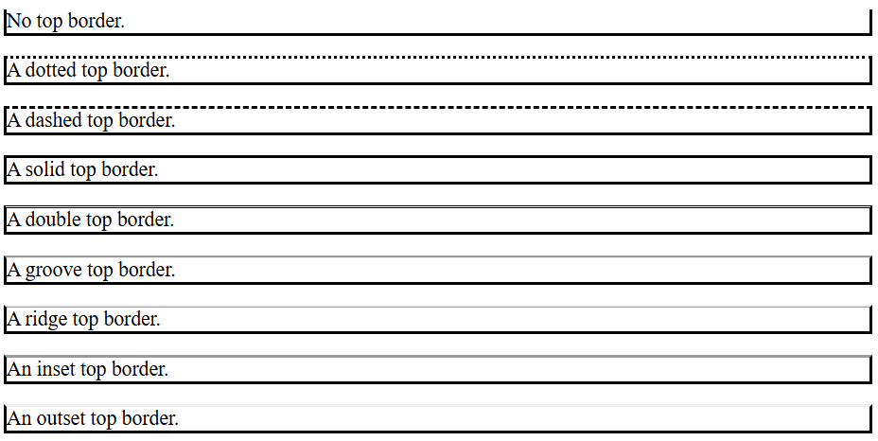
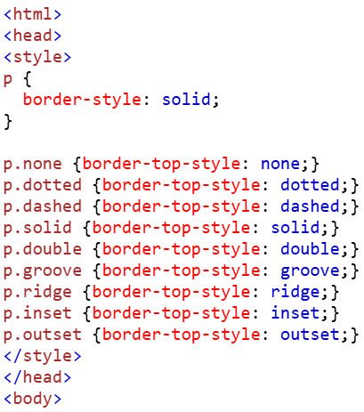
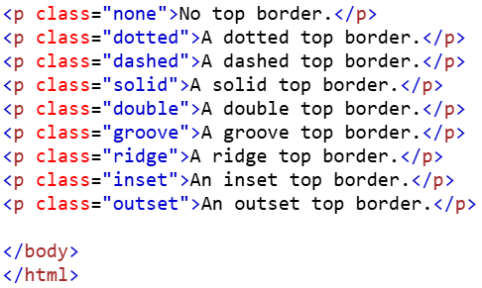
border-bottom-style
border-left-style
border-right-style
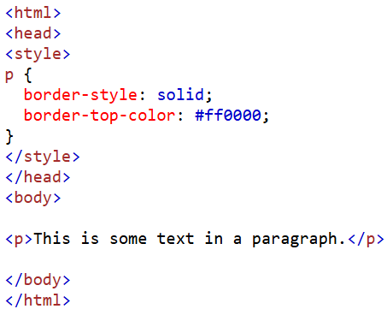
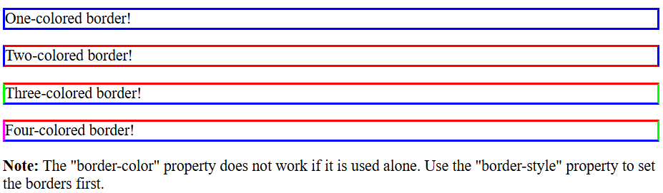
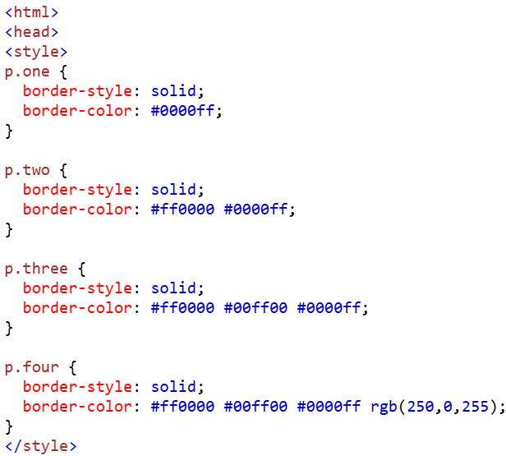
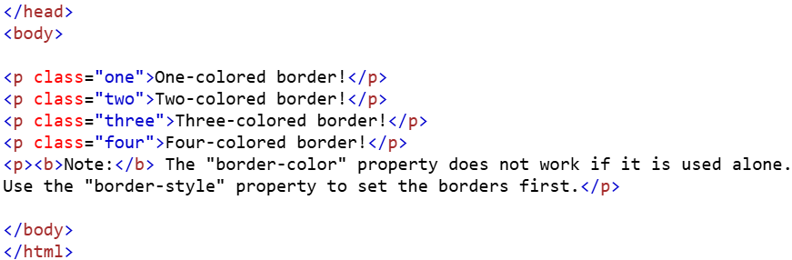
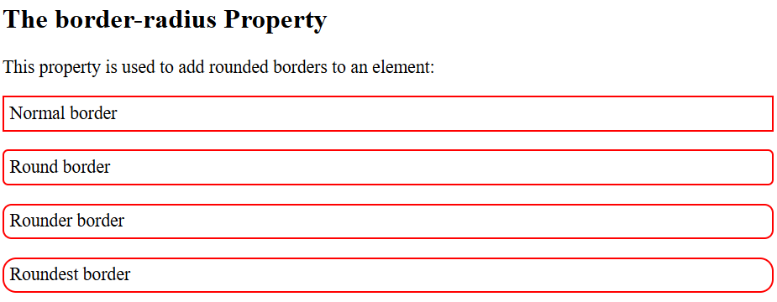
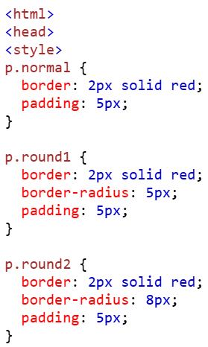
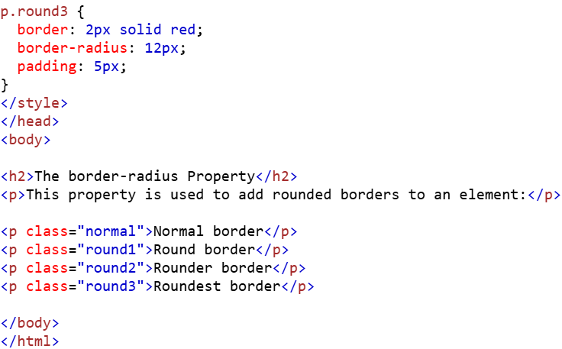
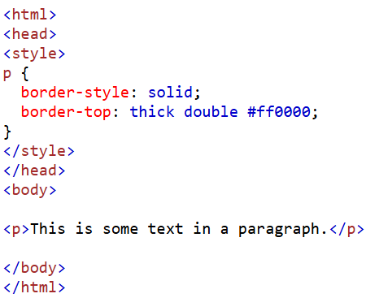
Padding Property
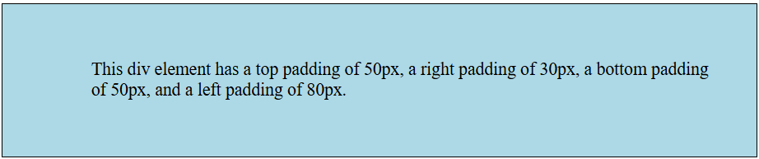
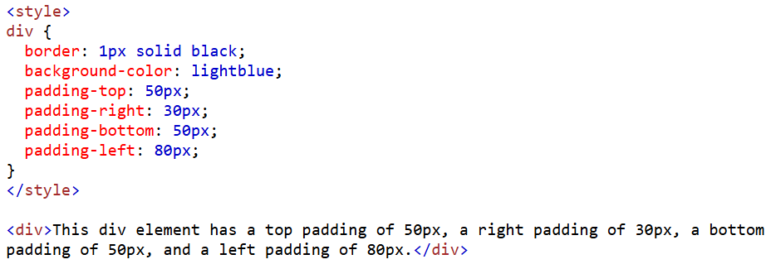
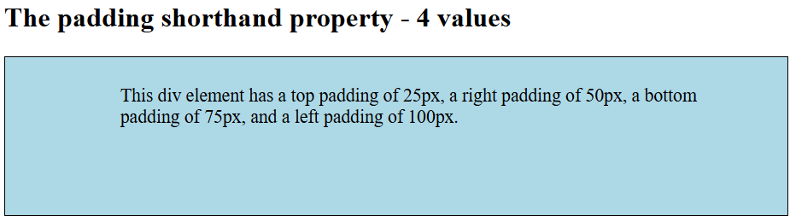
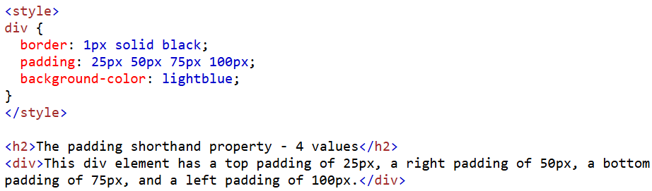
padding: 25px 50px 75px;
This div element has a top padding of 25px, a right and left padding of 50px, and a bottom padding of 75px.
padding: 25px 50px;
This div element has a top and bottom padding of 25px, and a right and left padding of 50px.
padding: 25px;
This div element has a top, bottom, left, and right padding of 25px.
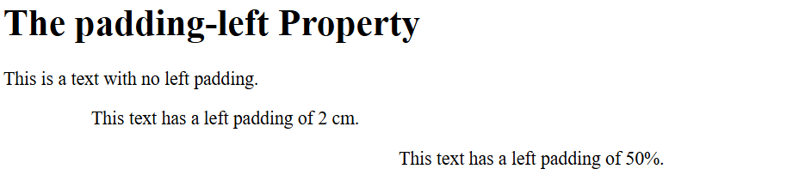
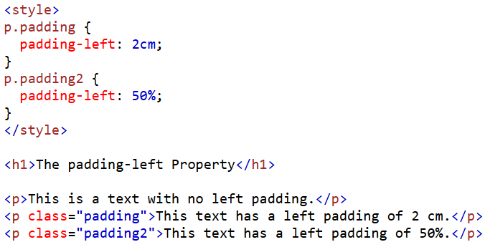
padding-right: 2cm;
padding-top: 2cm;
padding-bottom:2cm;
padding-right: 50%;
padding-top: 50%;
padding-bottom:50%;

Margin Property
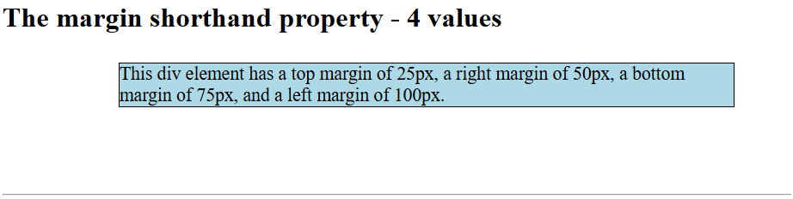
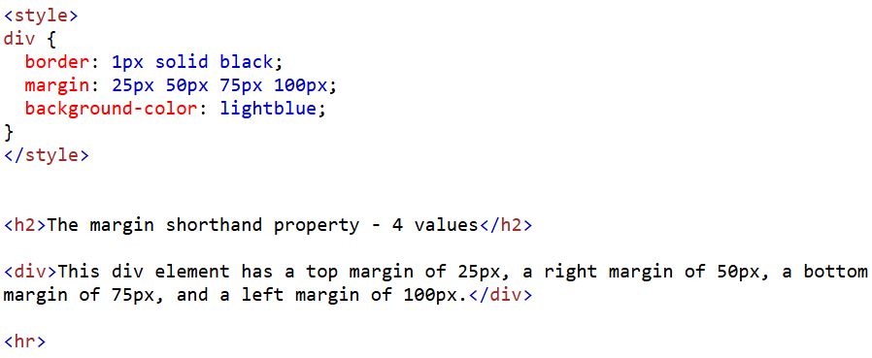
margin: 25px 50px 75px;
This div element has a top margin of 25px, a right and left margin of 50px, and a bottom margin of 75px.
margin: 25px 50px;
This div element has a top and bottom margin of 25px, and a right and left margin of 50px.
margin: 25px;
This div element has a top, bottom, left, and right margin of 25px.
margin: auto;
horizontally centered
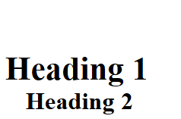
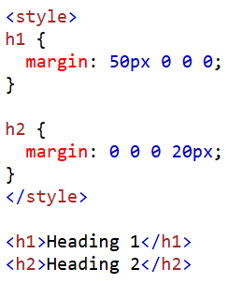
Box Model
